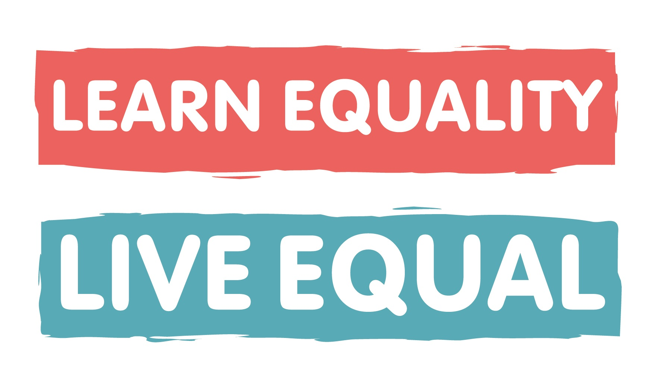
Learn Equality,

Live Equal

Media consent form
We ask that you carefully review our media consent policy. If you have questions or concerns about your child’s image being used by the National Children’s Bureau please speak to your school or contact us on learnequality@ncb.org.uk.
Schools must submit this form if their submission to the Virtual Display Board provides identifiable details about pupils and other individuals, for example images.

How are the images used?
We will use images to form part of a Virtual Display Board – a collection of case studies and examples of work carried out by schools participating in the Learn Equality, Live Equal programme, managed by the Sex Education Forum (SEF) and Anti-Bullying Alliance (ABA), both hosted by the National Children’s Bureau (NCB). This will be hosted online and available for public viewing.
Any submission to the Virtual Display Board may be uploaded to the NCB, ABA and SEF websites, shared via their social media networks or used as part of internal programme reports.

As a parent/primary carer of __________________________________ (child/young person’s name)

a student at _________________________________________ (Name of school) you hereby agree to:
- Allow National Children’s Bureau to use and reproduce photographs, images, and video footage of your child as outlined above.
- Allow National Children’s Bureau to securely store images and video footage of your child for the purpose of the Learn Equality, Live Equal Virtual Display Board.

________________________________________ _______________________________________
Parent/Carer Signature Date

Media consent policy
The National Children’s Bureau agrees to:
- Only use images of young people with their consent and the consent of their parent or carer.
- Store images and video footage of young people securely and only for a limited time (until March 2024.
- Use images and video footage of young people as set out on the consent form, and with the aim to further the mission of the National Children’s Bureau to address homophobic, biphobic and transphobic bullying.
- Never publically fully identify a young person in conjunction with an image. We may use partial information such as school/organization and region.
- Remove images or footage of young people upon written request by themselves or their parent or carer. Upon receipt of the request online photographs will be removed immediately and printed or published footage will be removed for subsequent print runs and editions.

