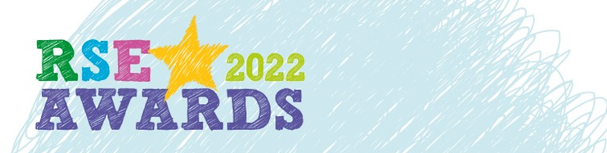

**Sex Education Forum is delighted to launch the RSE Awards 2022 – celebrating excellence in teaching relationships and sex education.**

We are calling for entries from educators working within school and youth settings. Entries can be made under one of three categories:

* **Educator of the year for inclusive RSE**Open to individuals working in schools and other youth settings
* **Educator of the year for most improved RSE provision**Open to individuals working in schools only
* **Educator of the year for innovation in RSE**Open to individuals working in any named organisation

Don't wait to be nominated! Put yourself forward and seek the support of either young people, parents, governors/trustees, or colleagues for your entry. If you know an educator with star quality please encourage them to apply and lend your support to their entry.

**To enter you’ll need to follow these steps**

1. Choose which award to enter for
2. Write up to 300 words about your RSE provision
3. Prepare one piece of supporting evidence (optional)
4. Secure support from 2 people who will be named on the entry form
5. Share information about the entry with a senior colleague e.g. Headteacher
6. Submit your entry by email to [info@sexeducationforum.org.uk](mailto:info@sexeducationforum.org.uk) **by 20 June 2022**

A judging panel including young people will decide on the winners, to be announced at the Sex Education Forum summer event on **5 July 2022.**

**Award criteria**

There are five judging criteria for each award. The first criterium is specific to the award title, followed by four common judging criteria which apply to all the awards.

**The first judging criteria is specific to each award title:**

* **Educator of the year for inclusive RSE**Is there evidence of identifying and addressing specific needs of children and young people relating to one or more of the protected characteristics defined in the Equality Act?
* **Educator of the year for most improved provision**Is there evidence of identifying areas of practice that needed improving and action taken to improve them?
* **Educator of the year for innovation in RSE**Is there evidence of identifying and addressing a problem or issue that required an innovative response?

**Plus these four judging criteria, which are common to all awards:**

1. Is there evidence that children and young people were involved in the design and delivery of their RSE, with examples of the feedback received?
2. Is there evidence that RSE is safe and fully inclusive, so that all children and young people feel included and OK about taking part?
3. Will the RSE that is offered now be able to carry on in the future, even if the educator that has been nominated isn’t there?
4. Does the RSE have ‘star quality’, something that makes it really excellent and exceptional?

Please use the space overleaf to explain, **in up to 300 words,** how your RSE provision fulfills the five criteria for the chosen award.

To support your nomination you are invited to add:

* photos, drawings, samples of children and young people’s work (these could be collected in a word document or slides – maximum 10 pages), or
* a short video clip please upload your video as a private YouTube video and send us a link. No more than 2 minutes in length.

Maximum one piece of supporting evidence can be provided per application.

We will keep your data secure, it will only be used for the purpose of this competition and we will only hold personal data until December 2022 when it will be deleted.

**Details of entrant**

Name of educator entering the RSE award: TYPE HERE

Job title of person entering the RSE awards:

Which RSE award are you entering? Delete as appropriate

**Educator of the year for inclusive RSE / most improved provision / innovation in RSE**

Email address of entrant:  
  
Postal address of entrant:

**Support for the entry**

Name of (1st) person supporting this entry: TYPE HERE

Role of person entering the RSE awards (for example young person, parent, governor, teacher):

Name of (2nd) person supporting this entry:

Role of person entering the RSE awards (for example young person, parent, governor, teacher):

**Statement of support from Head teacher or senior colleague**

I have approved this nomination and, if there are any photos or identifiable information have consent to use the photos for the purpose of this competition. [Sex Education Forum will contact you if we would like to use these images].

Name: TYPE HERE

Email address:

Telephone number:

Please note that we will contact the named Headteacher or Assistant Headteacher should this be a winning nomination.

**Your entry** (please write up to 300 words)

TYPE HERE